**Aim:** Conditional Formatting in Excel

**IDE:** Excel

# Theory:

Conditional formatting is a powerful feature in Microsoft Excel that allows users to apply formatting rules to cells or ranges based on specified conditions. With conditional formatting, users can visually highlight important data, identify trends, and quickly spot anomalies in their Excel spreadsheets. In this detailed guide, we will explore the various aspects of conditional formatting in Excel, including its benefits, how to apply conditional formatting rules, common use cases, and advanced techniques.

# What is Conditional Formatting?

Conditional formatting is a feature in Excel that allows users to apply formatting styles, such as font color, fill color, and cell borders, based on specific conditions or criteria. These conditions can include numerical values, text strings, dates, and formula-based rules. Conditional formatting helps users to quickly interpret and analyze data by visually emphasizing certain aspects of the data set.

# Benefits of Conditional Formatting:

1. Enhanced Data Visualization: Conditional formatting enables users to visualize data trends, patterns, and outliers more effectively, making it easier to interpret complex datasets.
2. Improved Data Analysis: By highlighting data that meets certain criteria or conditions, conditional formatting facilitates quick analysis and identification of important information.
3. Increased Productivity: Conditional formatting automates the process of formatting cells based on predefined rules, saving time and effort for users.
4. Customization and Flexibility: Users have the flexibility to customize conditional formatting rules according to their specific requirements, allowing for greater control over the appearance of their Excel spreadsheets.

# How to Apply Conditional Formatting:

Applying conditional formatting in Excel involves the following steps:

1. Select the Data Range: First, select the range of cells to which you want to apply conditional formatting.
2. Open the Conditional Formatting Menu: Go to the "Home" tab on the Excel ribbon, then click on the "Conditional Formatting" button in the Styles group. This will open a dropdown menu with various conditional formatting options.
3. Choose a Formatting Rule: Select one of the predefined formatting rules from the dropdown menu, such as "Highlight Cells Rules" or "Top/Bottom Rules." Alternatively, you can create a custom formatting rule based on specific criteria.
4. Set the Formatting Options: Configure the formatting options for the selected rule, such as the formatting style, color, and font settings. You can also specify the criteria or conditions that determine when the formatting should be applied.
5. Apply the Formatting Rule: Once you have set up the formatting options and criteria, click "OK" to apply the conditional formatting rule to the selected range of cells.

# Common Use Cases for Conditional Formatting:

1. Highlighting Duplicate Values: Use conditional formatting to identify and highlight duplicate values within a dataset, making it easier to spot inconsistencies or errors.
2. Data Bars and Color Scales: Apply data bars or color scales to visually represent the relative values of cells within a range, allowing for quick comparison and analysis.
3. Threshold Alerts: Set up conditional formatting rules to trigger alerts or warnings when certain thresholds or limits are exceeded, such as budget targets or sales quotas.
4. Date-Based Formatting: Apply conditional formatting to date columns to highlight upcoming deadlines, important events, or overdue tasks.
5. Traffic Light Icons: Use conditional formatting to display traffic light icons (green, yellow, red) based on the values of cells, indicating performance levels or status indicators.
6. Conditional Formatting with Formulas: Create custom conditional formatting rules using Excel formulas to apply more complex formatting based on dynamic conditions.

# Advanced Techniques and Tips:

1. Manage Conditional Formatting Rules: Use the "Conditional Formatting Rules Manager" to view, edit, or delete existing conditional formatting rules in your workbook.
2. Combine Multiple Rules: Apply multiple conditional formatting rules to the same range of cells to create layered effects or prioritize certain formatting rules over others.
3. Use Named Ranges: Define named ranges for your data to make it easier to apply and manage conditional formatting rules across multiple worksheets or workbooks.
4. Apply Formatting to Entire Rows or Columns: Use conditional formatting formulas that reference entire rows or columns to apply formatting dynamically as data changes.
5. Conditional Formatting with Pivot Tables: Apply conditional formatting to pivot tables to visualize trends and patterns in summarized data.

# Pre Lab Exercise:

* 1. What is the use of scenario manager?
  2. What is the use of the Data tables option in WhatIF analysis?
  3. What is the use of Goal Seek?

# Tasks:

For the given dataset:

|  |  |  |  |  |  |  |
| --- | --- | --- | --- | --- | --- | --- |
| NAME | REGION | RESULT | RESULT (1,0) | TEST DATE | AGE | Fruits |
| Name 1 | North | Negative | 0 | 28-03-2024 | 18 | Apple |
| Name 2 | East | Negative | 0 | 28-03-2024 | 86 | Banana |
| Name 3 | South | Positive | 1 | 23-03-2024 | 20 | Orange |
| Name 4 | South | Negative | 0 | 28-03-2024 | 100 | Mango |
| Name 5 | South | Negative | 0 | 26-03-2024 | 90 | Pineapple |
| Name 6 | East | Positive | 1 | 24-03-2024 | 68 | Apple |
| Name 7 | South | Negative | 0 | 29-03-2024 | 71 | Apple |
| Name 8 | North | Negative | 0 | 30-03-2024 | 24 | Mango |
| Name 9 | North | Negative | 0 | 28-03-2024 | 86 | Orange |
| Name 10 | North | Negative | 0 | 28-03-2024 | 56 | Orange |
| Name 11 | North | Negative | 0 | 03-04-2024 | 76 | Mango |
| Name 12 | South | Negative | 0 | 15-03-2024 | 70 | Apple |
| Name 13 | North | Positive | 1 | 17-03-2024 | 35 | Apple |
| Name 14 | North | Negative | 0 | 28-03-2024 | 53 | Orange |

Perform the following tasks:

1. Format cell according to its value: Format all entries from the South region

# Results:

1. Explore preset rules (and some alternative formats): Format top 3 ages // ages above average

**Results:**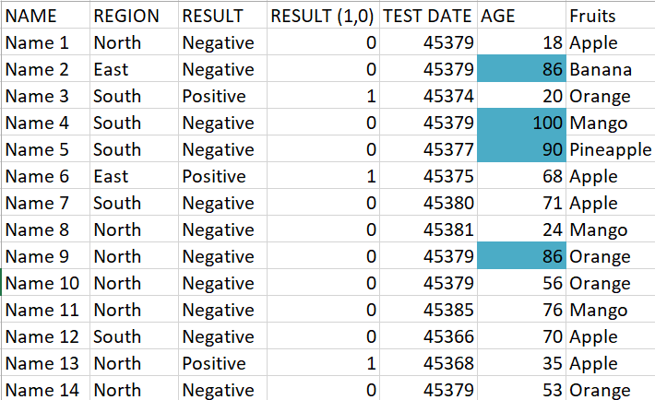

1. Implement icons and color scales: Format age with a color scale // result with icon

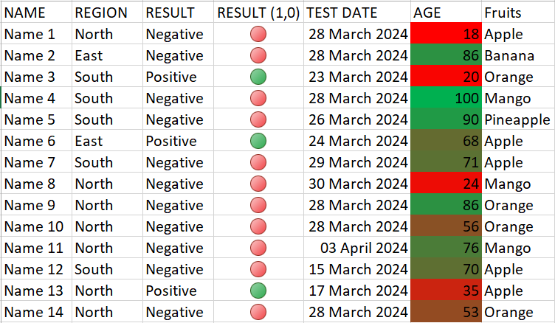**Results:**

1. Format cell according to another cell's value: Format name if age above 85

**Results:-**

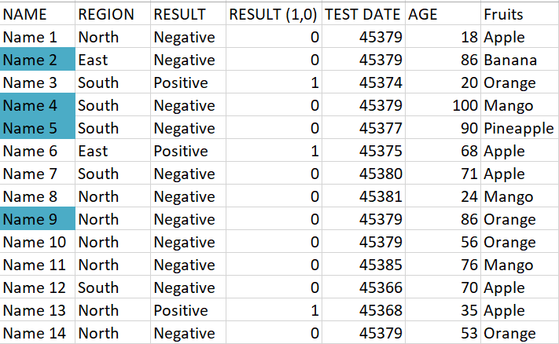

1. Format dates in (or outside of) a date range: Format test older than 7 days

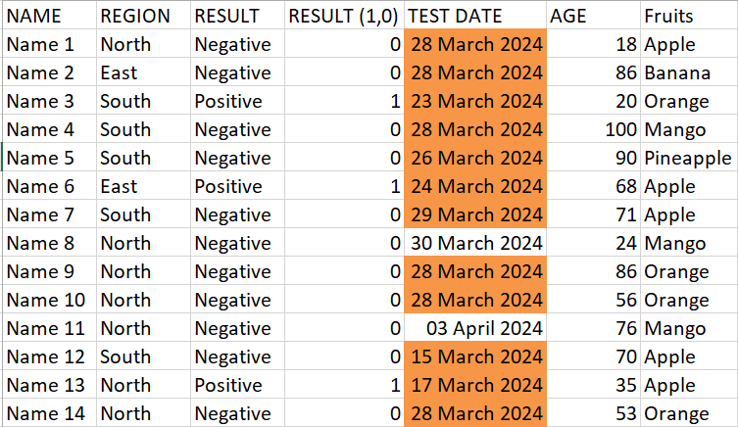**Results:**

# Observation and Result Analysis:

Write the final observation and process corresponding to each task

**1. _ _ _**

**_ _ _**

**2. _ _ _**

**_ _ _**

**3. _ _ _**

**_ _ _**

**4. _ _ _**

**_ _ _**

**5. _ _ _**

**_ _ _**

# Post Lab Exercise:

You are working as an analyst at a retail company, and you have been tasked with analyzing sales data for different product categories across multiple regions. Your manager has provided you with a dataset containing sales figures for the past year, organized by product category (e.g., electronics, clothing, furniture) and region (e.g., North America, Europe, Asia).

Your objective is to use conditional formatting in Excel to visually highlight key insights and trends in the sales data, with a focus on identifying top-performing product categories and regions.

# Questions:

* 1. 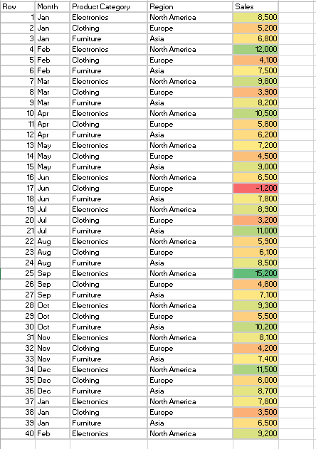Using conditional formatting, create a heat map to visualize the sales performance of different product categories across regions. Which product categories appear to have the highest sales figures, and in which regions?
  2. Apply conditional formatting to identify outliers in the sales data. Are there any product categories or regions with unusually low or high sales figures compared to the rest of the dataset?

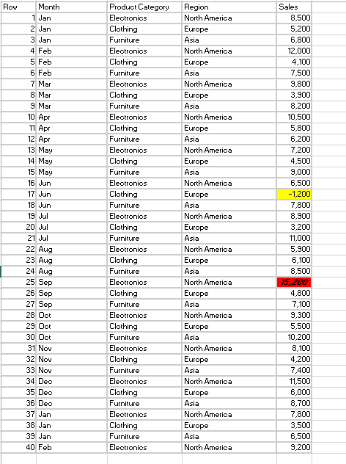

* 1. Create a conditional formatting rule to highlight cells with sales figures that exceed a certain threshold (e.g., $10,000). How many cells meet this condition, and which product categories and regions do they belong to?

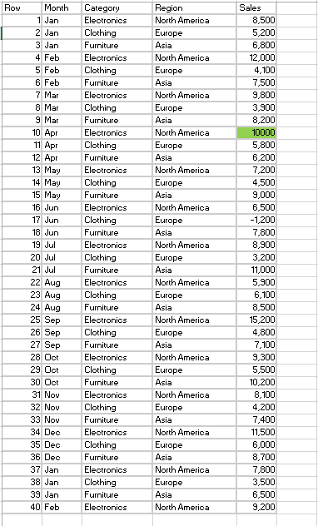

* 1. Use conditional formatting to highlight cells with negative sales figures, indicating a loss. How many such cells are there, and which product categories and regions are affected?

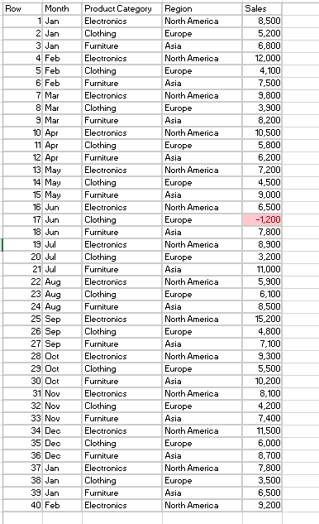

* 1. Apply color scales to visualize the distribution of sales figures within each product category. Do you observe any patterns or trends in the sales data based on the color scales?

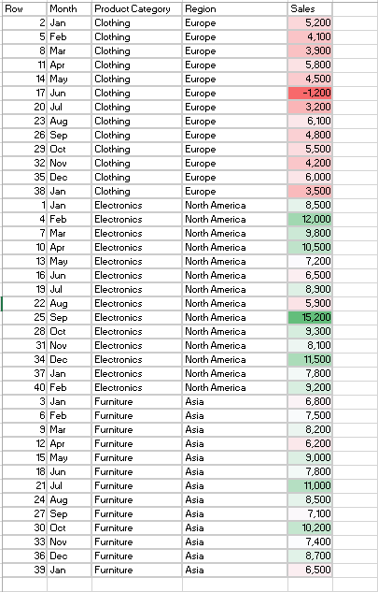

* 1. Implement conditional formatting rules to identify cells with consecutive months of declining sales. How many instances of declining sales are there, and which product categories and regions are affected the most?

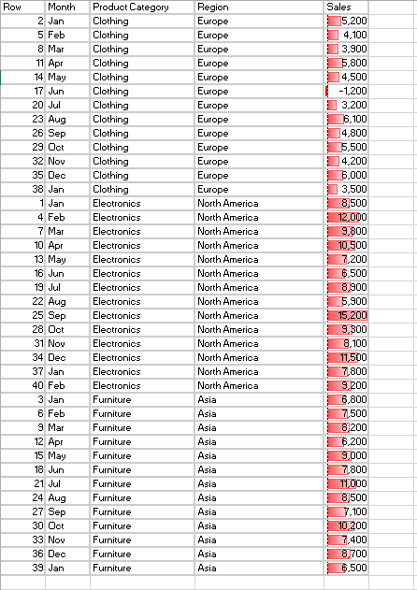

* 1. Create a conditional formatting rule to highlight cells with significant month-over-month increases in sales (e.g., exceeding 20%). How many such instances are there, and which product categories and regions show the most growth?

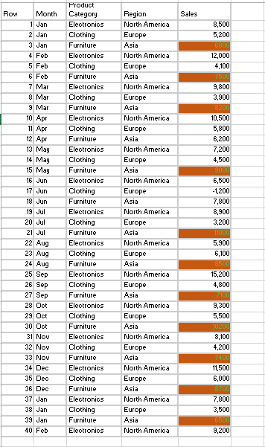

* 1. Combine conditional formatting rules to create a multi-layered visualization of the sales data, incorporating color scales, data bars, and icon sets. How does this comprehensive visualization enhance your understanding of the sales performance across different categories and regions?

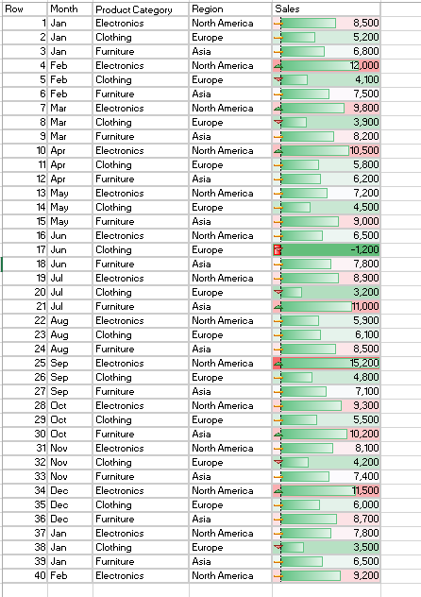

* 1. Apply conditional formatting to highlight cells containing sales figures that fall within specific percentile ranges (e.g., top 10%, bottom 25%). Which product categories and regions fall into these percentile ranges, and what insights can be gleaned from this analysis?

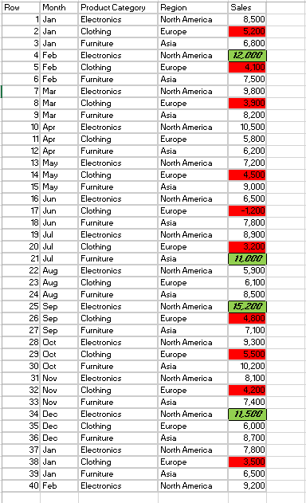

* 1. Finally, based on your analysis using conditional formatting, provide recommendations to the management team regarding potential areas for improvement or further exploration, such as focusing on high-growth product categories or implementing targeted marketing strategies in underperforming regions.
* The first thing I should say is that they need to address the very low sales of cloths as it consistently low and in loss in a case also the sales in North America are very high, they are having high demand of the electronics. Aisa seems to doing good in terms of furniture but is behind the NA in electronics. The top performing product category is electronics